Busy Accounting Software Syllabus (2 MONTHS)
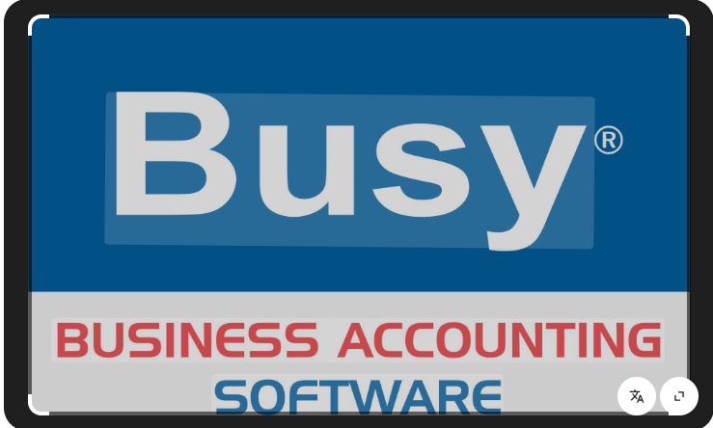
Module 1: Introduction to Busy Software
- Overview of Busy Accounting
- Versions of Busy (Basic, Standard, Enterprise)
- Installation and Setup
- Features & Benefits

Module 2: Company Creation & Configuration
- Creating a Company
- Setting Financial Year
- Configuring Company Features (VAT, GST, Inventory, etc.)

Module 3: Master Entries
- Ledger Creation
- Group Creation
- Stock Item & Stock Group
- Unit of Measurement
- Tax Masters (GST, TDS)

Module 4: Voucher Entry
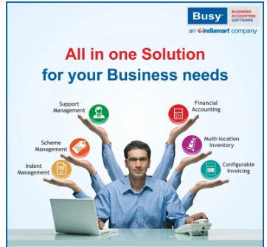
- Purchase Voucher (GST Input)
- Sales Voucher (GST Output)
- Payment/Receipt/Journal Vouchers
- Debit/Credit Notes
- POS Billing

Module 5: Inventory Management
- Stock Valuation
- Godown Management
- Batch-wise Inventory
- All Shortcut Keys

Module 6: GST in Busy
- Enabling GST
- Creating GST Masters
- GST Billing (Intra & Inter-State)
- HSN/SAC Codes
- Short Question Answer for Interview
Module 7: Reports & Analysis
- Trial Balance
- Profit & Loss
- Balance Sheet
- Cash/Bank Book
- Day Book
- GST Reports

Module 8: Data & Security
- Backup & Restore
- User Management & Security Control
- Audit Feature
- Exporting Reports to Excel/PDF

Module 9: Advanced Features (Optional)
- Multi-Currency Handling
- Budgeting/ MIS Reports

